UNIT TITLE: BIT 4107 MOBILE APPLICATION DEVELOPMENT
Compiled by: Kefa Vincent BIT/2024/54140
PROJECT NAME: Educlear
APPLICATION USED: Android studio
LANGUAGE USED: Kotlin
LECTURER NAME: Mr. Michael Nyoro

Introduction to the Educlear
The EduClear Student Clearance Management System is a mobile application developed in Android Studio using Kotlin and XML layout frameworks. The application is specifically engineered to streamline, digitize, and track the traditionally tedious university graduation clearance process for students and also for high schools during final year.

Project Objectives:
1. Automate the student clearance process
- Replace manual, paper-based clearance with a digital workflow to reduce delays, lost forms, and repeated follow-ups across departments.
2. Centralize clearance status tracking
- Provide students and admin staff with real-time visibility of clearance status from all required departments: library, finance, hostel, academics, etc.
3. Improve communication between departments and students
- Enable instant notifications and updates so students know exactly which department is pending and what action is needed.
4. Reduce administrative workload
- Allow department heads to approve or reject clearance requests within the app, eliminating physical queues and manual sign-offs.
5. Ensure data accuracy and auditability
- Maintain a secure, timestamped record of all approvals and rejections for easy audits and future reference.

Installation Steps
How to download Android Studio
- Open your web browser and navigate to the official developer portal: developer.android.com/studio.
- Click the prominent "Download Android Studio" button.
- Accept the Google Terms and Conditions checkbox to initiate the download.

Steps for installation
• Double-click the downloaded executable file (usually named android-studio-xxxx-windows.exe).
• If a User Account Control (UAC) prompt pops up asking for permission, click Yes.
• In the Setup Wizard, click Next.
• Choose Components: Ensure both Android Studio and Android Virtual Device (AVD) are checked, then click Next.
• Choose your preferred installation location (the default path in C:\Program Files\Android\Android Studio) and click Next.
• Click Install. Once the progress bar fills up, click Next and then Finish to launch Android Studio.
THE SCREENS BELOW SHOW THE STEPS DURING ISTALLATION;

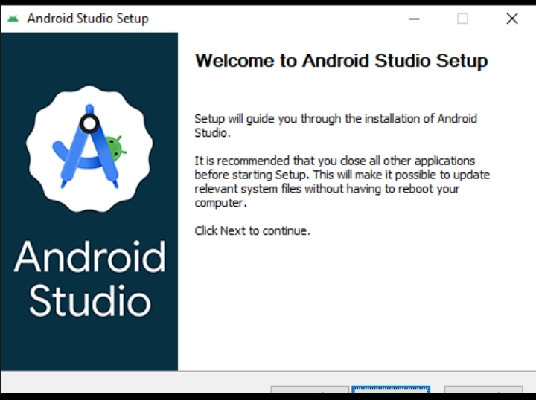
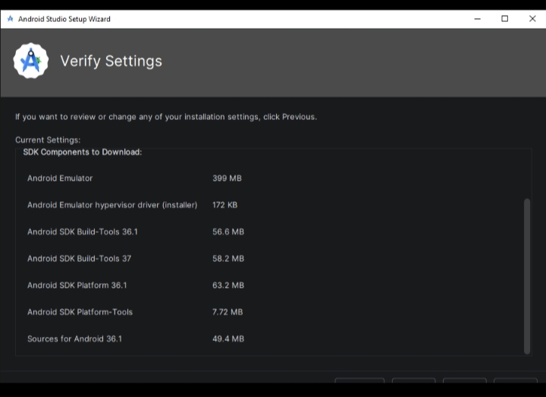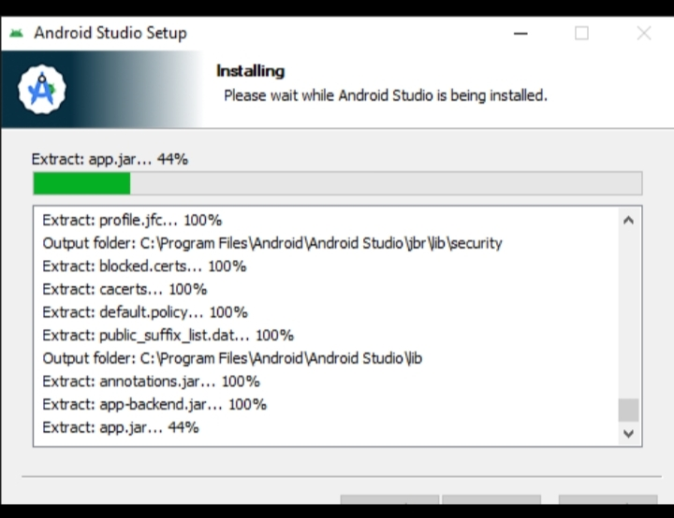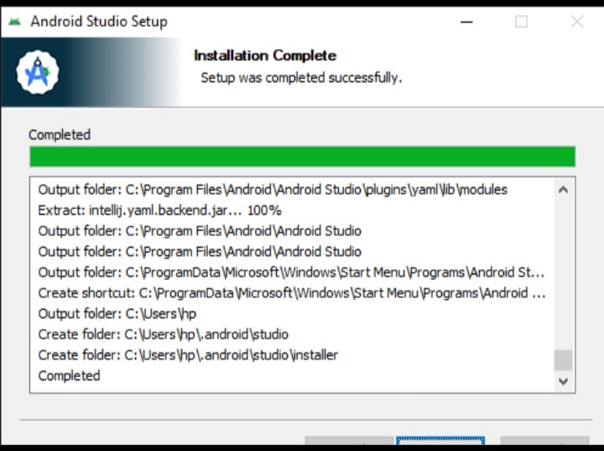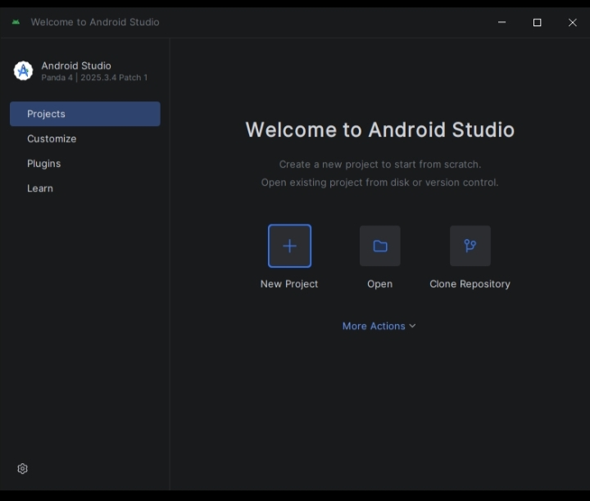
Weekly Objectives
Week 1: Introduction to Mobile Application Development
- Splash Screen Interface: Formulated a branded entry layout containing the application logo, a circular loading vector asset, and custom typography.
- Login Screen: Built an authentication gate utilizing input text fields wrapped in TextInputLayout for credential validation.
Week 2: Mobile Development Environment & Dependencies
- Build Configuration: Customized the app-level build.gradle.kts configuration file. Imported external dependencies including Material Design 3 libraries and the Retrofit 2 ecosystem for HTTP networks.
Week 3: User Interface (UI) Design
- Dashboard: Designed a functional grid-based layout for administration privileges.
- Structured an interface that gives students real-time feedback on their clearance progress across departments.
Week 4: Event Handling and User Interaction
- Navigation Control: Wired a structural BottomNavigationView using programmatic click listeners to switch out display spaces between Home and Profile contexts.
Week 5: Data Management & Database Design
- Database Schemas: Designed a relational structure inside a local MySQL server instance containing structured tables for students, administration staff, and unique status tracking entries.
Week 6: Networking and APIs
- Integrations: Wrote backend PHP processing scripts to parse incoming HTTP POST request vectors, query the local database, and serve JSON payloads back to the client application..
Week 7: Application Architecture
- Admin/Student Routing Logic: Built a conditional branching routine inside the landing runtime logic that checks user access scopes to direct the application to either the student dashboard or administration console.
Week 8: Project Planning & Component Assembly
- Admin Management Hub: Configured a custom UI console housing a structural RecyclerView designed to stream and render student records.
Week 9: Device Features and Themes
- Dynamic UI Adaptations: Refactored layout resource hooks to natively adapt to system-wide themes. Programmed color variables to shift between a gold palette for admins and a corporate blue palette for students.
Week 10: Notifications and Background Services
- Implemented an automated background check routine using the WorkManager API. This service polls the backend server at set intervals to check for changes in student clearance status.
Week 11: Testing and Debugging
- Conducted automated and manual testing. Used Android Studio's Logcat filtering tools to catch runtime Exceptions and trace memory leaks.

Screenshots of progress
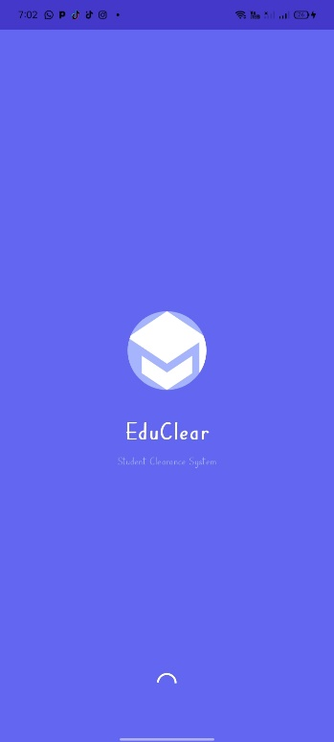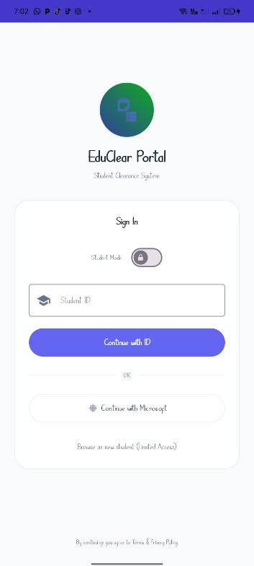
Screenshots of login screen
Screenshots of admin and student dashboard, profile and student data

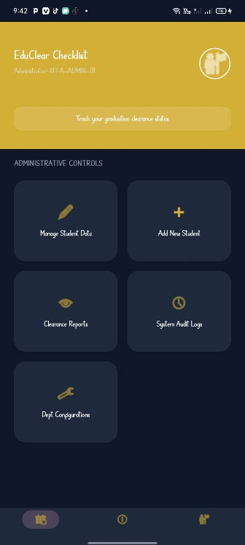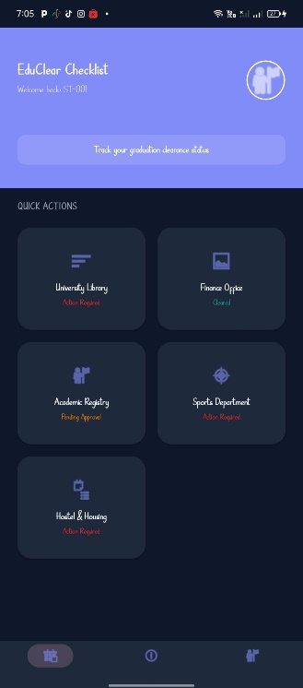

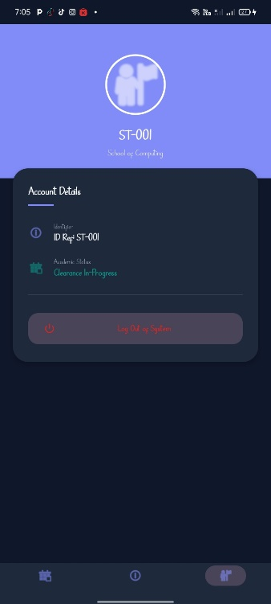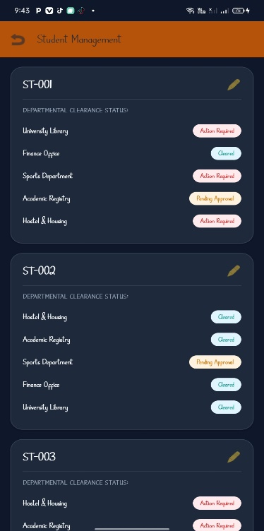
Activities Completed
- Android Environment Setup & Dependency Configuration:
  - Completed a step-by-step installation and optimization of Android Studio.
  - Configured hardware acceleration (HAXM/Hypervisor) for x86_64 Virtual Devices.
  - Integrated modern architecture dependencies into the build.gradle configuration file, including Material Design 3 UI components and the Retrofit 2 networking ecosystem.
- Authentication Engine & Role-Based Routing:
  - Built a branded SplashActivity entry screen featuring the application logo and a vector loading bar to handle initial resource loading.
  - Developed a LoginActivity with strict programmatic input validation rules using Material TextInputLayout.
  - Implemented a conditional backend-driven router switch in Kotlin that reads user access scopes to branch the application into two entirely separate functional modes: Student Mode and Admin Mode.
- Dynamic User Dashboards (Dual-Portal System):
  - Student Dashboard: Designed a centralized, high-aesthetic layout utilizing deep rounded corners, surface shadows, and card elevations where students can track their real-time clearance status across various university departments.
  - Admin Management Hub: Engineered an administrative management console featuring a high-performance RecyclerView and MaterialCardView components that allow administrators to view, filter, and modify individual student clearance statuses in just two clicks.
- Full-Stack API Integration & Relational Database Design:
  - Designed and structured relational database tables (tbl_students, tbl_admins, tbl_clearance) within a local MySQL database engine managed via phpMyAdmin.
  - Wrote custom PHP server scripts hosted on a local XAMPP Apache Server to process secure HTTP POST network traffic, run queries, and stream structured data back to the mobile client as JSON payloads parsed via the GSON library.
- Global Layout Navigation & Context Preservation:
  - Implemented an interactive BottomNavigationView bar linked directly to programmatic click listeners (setOnClickListener).
  - Integrated explicit Activity Intents combined with Intent.putExtra() data bundles to pass key-value payload data (such as User IDs) across activities, ensuring the user's session context stays active from the login screen to the profile dashboard.
- Theme Adaptability & Dynamic Branding:
  - Refactored all application layout files to natively adapt to system-wide settings using configuration qualifiers (-night) for full Dark Mode support.
  - Programmed the system UI themes to shift dynamically based on role authorization: changing to a Gold Palette to represent the corporate Admin Mode and an Indigo Blue Palette for the Student Mode without duplicating design assets.
- Automated Background Daemons & Status Notification Channels:
  - Constructed a background polling worker via the Android WorkManager API that runs on a separate thread to periodically check for changes on the backend database.
  - Integrated the Android NotificationManager API to fire local status alerts on the user's lock screen the moment a department's status updates to "Cleared."
- Security Hardening, Testing, and Production Compilation:
  - Secured communication paths via network security configuration maps and replaced cleartext local preferences with the hardware-backed Jetpack EncryptedSharedPreferences API to protect user tokens.
  - Utilized Android Studio Logcat and JUnit4 to isolate runtime errors, verify data conversion models, and intercept network exceptions gracefully.
  - Configured ProGuard rules for code obfuscation and resource shrinking (minifyEnabled true), and generated a secure release keystore to sign and export the final Android App Bundle (.aab) for presentation.

Challenges Faced
• Theme Mismatch Crash: The app initially crashed when adding modern components (like TextInputLayout) because the theme was set to legacy AppCompat.
• Resource Linking Errors: Experienced "Resource not found" errors after refactoring hardcoded strings.
• UI Layout Issues: Problems with UI elements overlapping on smaller screens, specifically the dashboard header and profile logo.
• Data Persistence: Ensuring the user's login ID persisted and appeared correctly on the dashboard after navigating through multiple screens.

Solutions Implemented
• Material 3 Migration: Updated themes.xml to inherit from Theme.Material3.DayNight.NoActionBar. This resolved the component inflation crashes.
• String Resource Centralization: Performed a project-wide extraction of all text into app/src/main/res/values/strings.xml, fixing linking errors and enabling future localization.
• Responsive Layout Refactoring: Replaced static RelativeLayout structures with CoordinatorLayout and NestedScrollView, and used layout_toStartOf constraints to prevent overlaps.
• Intent Extra Handling: Implemented intent.putExtra("USER_ID", ...) in the login flow and retrieved it using intent.getStringExtra in the Dashboard to personalize the greeting.

Code Snippets
- Dynamic User Greeting (DashboardActivity.kt)
// Retrieve login ID and display personalized message
val userId = intent.getStringExtra("USER_ID") ?: "Student"
tvWelcome.text = getString(R.string.welcome_back_user, userId)

B. Modern Material 3 Button (activity_login_screen.xml)
<com.google.android.material.button.MaterialButton
android:id="@+id/btnContinueMicrosoft"
style="@style/Widget.Material3.Button.OutlinedButton"
android:layout_width="match_parent"
android:text="@string/continue_with_microsoft"
app:cornerRadius="27dp"
app:icon="@android:drawable/ic_menu_compass" />
Testing evidence
FEATURE | TEST CASE | RESULT
Login Validation | Attempt login with empty ID field. | PASSED: Error message "Please enter your Student ID" displayed.
Microsoft Login | Click "Continue with Microsoft". | PASSED: External browser opens Microsoft login portal.
Navigation | Click "Profile" icon on Bottom Nav. | PASSED: Screen switches to ProfileActivity correctly.
Clearance Update | Settle debt in Finance module. | PASSED: Dashboard badge updates from "Action Required" to "Cleared".

Reflections & Lessons Learnt
• Consistency is Key: Using a centralized colors.xml and strings.xml makes large-scale UI redesigns much faster and prevents "hardcoded string" bugs.
• M3 Benefits: Transitioning to Material Design 3 significantly improved the "look and feel" of the app with minimal extra code, thanks to its built-in styling for cards and buttons.
• Modular Thinking: Dividing the clearance process into separate activities (modules) made the project much easier to debug and scale compared to keeping everything on one screen.

